
ACTIVITY REPORT
ON
AI FRONTIERS WORKSHOP

1. Name of the Club: BMSCE ACM STUDENT CHAPTER
2. Name of the Activity: AI Frontiers Workshop
3. Objectives: The "AI Frontiers" workshop, conducted in collaboration with Hi-Devs, aimed to equip participants with foundational and advanced knowledge in Generative AI, Large Language Models (LLMs), and Retrieval-Augmented Generation (RAG). The event featured theoretical sessions, hands-on practice, and an exciting 36-hour hackathon to foster innovation and practical implementation.
4. Date, Time Venue of the Activity:
EVENT | AI Frontiers Workshop
DURATION | 14th to 19th November
TIME | Varied by activity (detailed below)
VENUE | PJA Block, 7th floor, AIML Seminar Hall

5. Name and details of collaborating agency
(if it is collaborative/joint activity): HI-DEVS

6. Brief summary of the Event:
· Day 1: November 14, 2024 (2 PM–4 PM)
Participants were introduced to the importance of Generative AI, LLMs,
and RAG. The session explored their real-life applications, addressing
misconceptions about AI displacing jobs, and highlighted how these
technologies complement human efforts.
· Day 2: November 15, 2024 (2 PM–4 PM)
The second session delved deeper into LLMs, covering their types, comparisons, costs, and token limits. Participants learned about decision trees and the processes these models use to generate context-based responses. Additionally, the concept of vector databases was introduced.
· Day 3: November 16, 2024 (9 AM–4 PM)
This was a hands-on coding session where participants worked with LangChain to implement Generative AI using LLMs. Practical exercises helped bridge the gap between theoretical understanding and application.
· Day 4 & 5: November 17–18, 2024 (12 PM–12 AM)
A 36-hour online hackathon saw 16-17 teams (2-4 members each) compete. The hackathon encouraged participants to solve innovative problem statements related to Generative AI and RAG. Problem statements were designed to avoid reliance on conversational AI tools.
· Day 6: November 19, 2024 (2 PM–5 PM)
Participants showcased their hackathon projects through demos and presentations. Winners were announced, with prizes awarded as follows:

- 1st Place: ₹3,000
- 2nd Place: ₹2,000
- 3rd Place: ₹1,000
- Additionally, eight participants received internships at Hi-Devs.
The AI Frontiers workshop successfully blended theoretical knowledge, practical coding sessions, and an innovative hackathon, creating a holistic learning experience. The collaboration with Hi-Devs added industry insights, making the event highly impactful for all participants.

7.Outcomes:
- The workshop witnessed 82 registrations, with participation from diverse backgrounds.
- Hands-on sessions and the hackathon provided practical exposure, enhancing participants' problem-solving and collaborative skills.
- 8 attendees secured internships with Hi-Devs, reflecting the workshop's industry relevance and impact.
- The event fostered awareness of the transformative potential of Generative AI and RAG, inspiring attendees to explore advanced AI technologies.

8. Registration Fees:
- ₹100 for non-ACM members
- ₹70 for ACM members

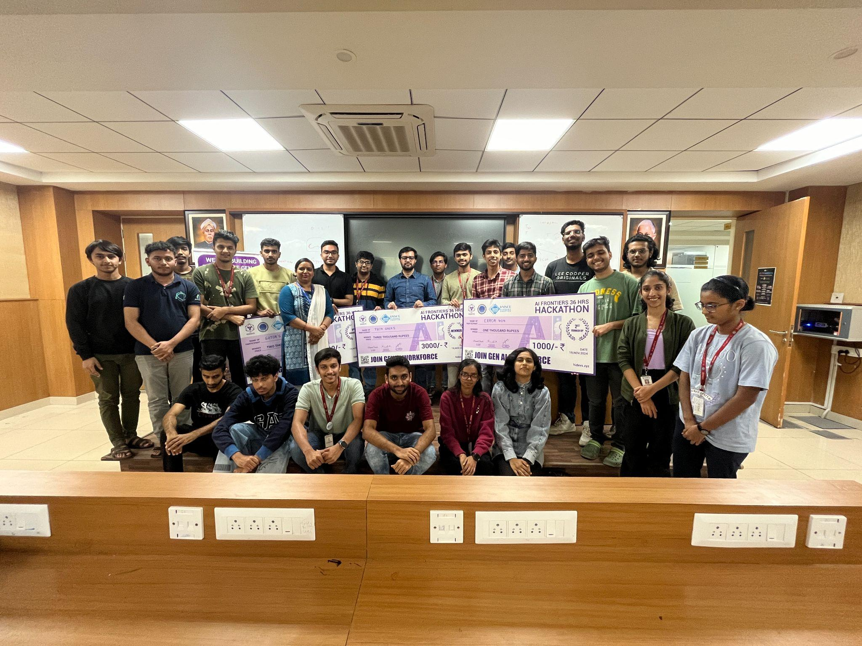
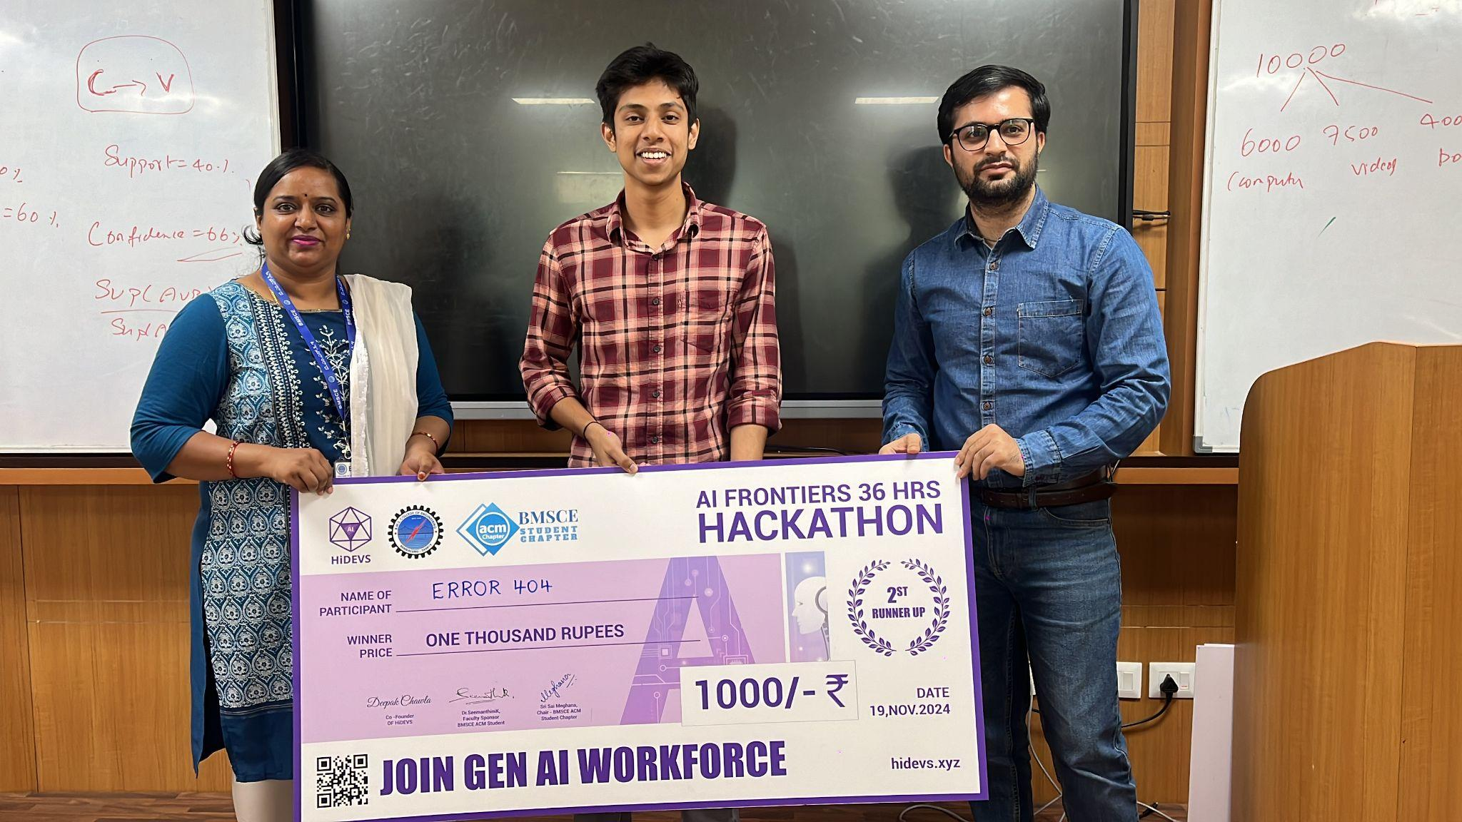
9. Photographs of the event:
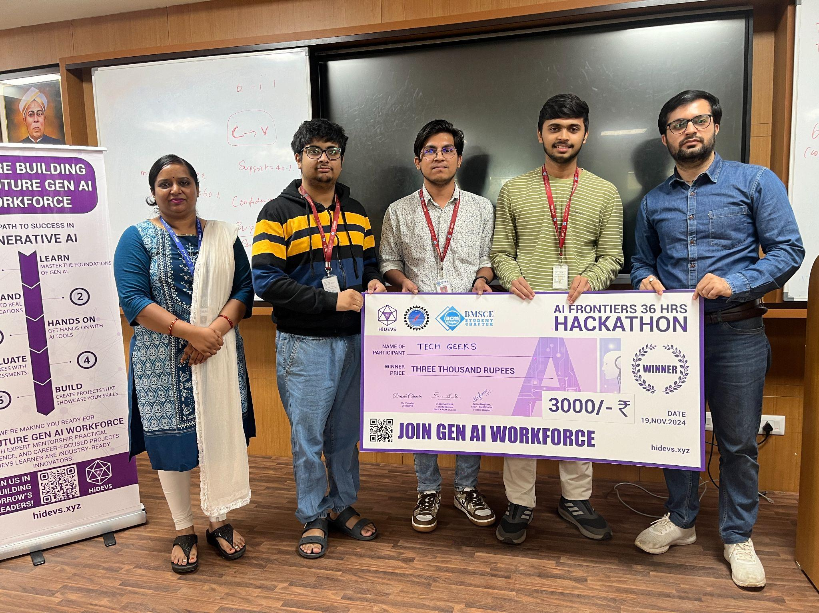
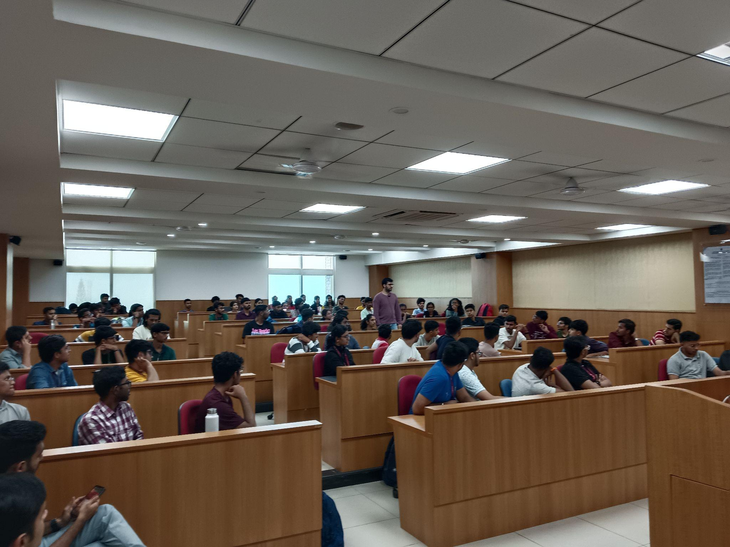
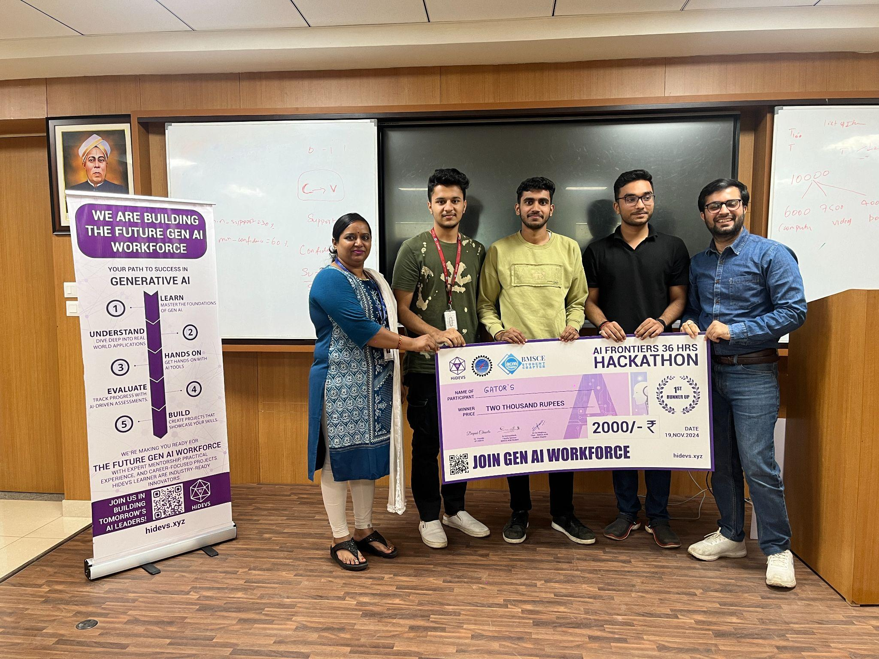

10. Supporting Documents:
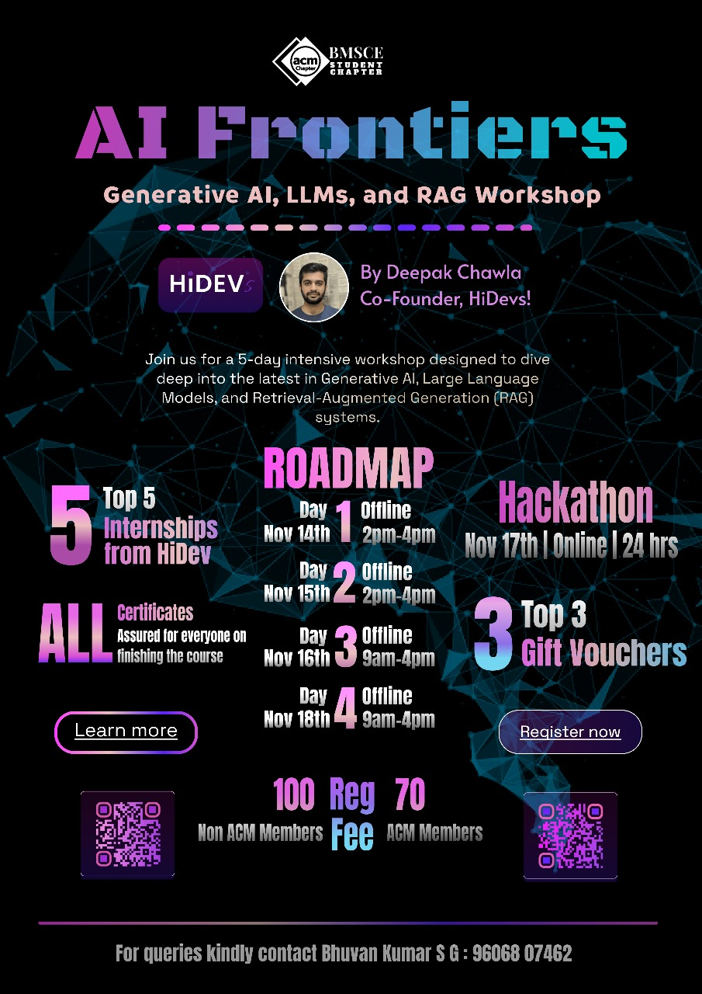
Circulars/Brochures:

